PHASE 5 – KAFKA PRACTICAL – FOLDER STRUCTURE AND PACKAGE, CODE EXPLANATION
Here we don’t remove RabbitMQ – we add kafka as an alternative, so we shall learn both and understand the difference.
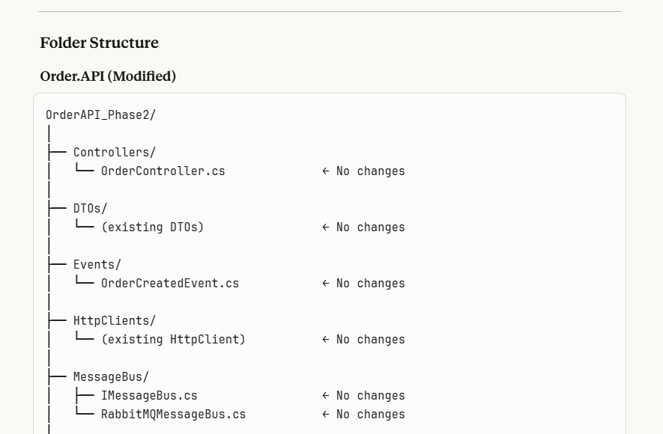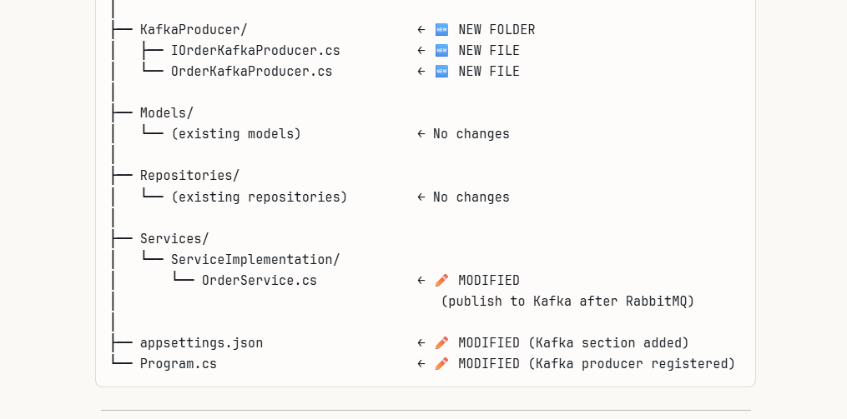
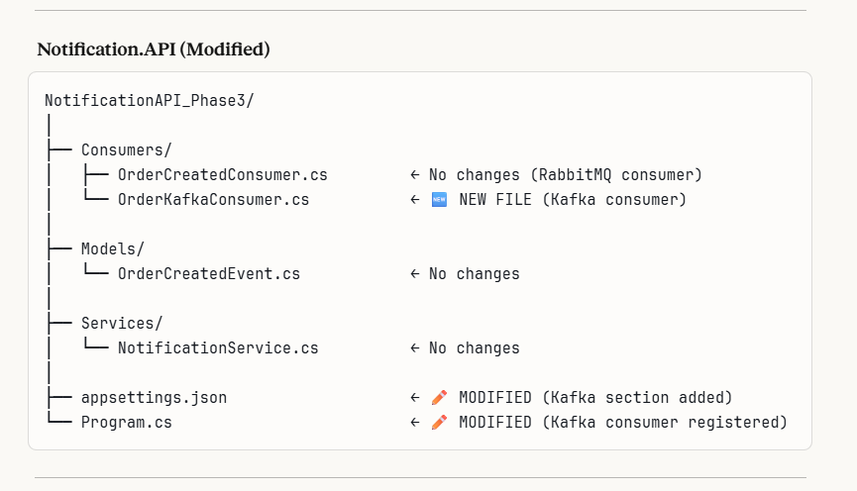
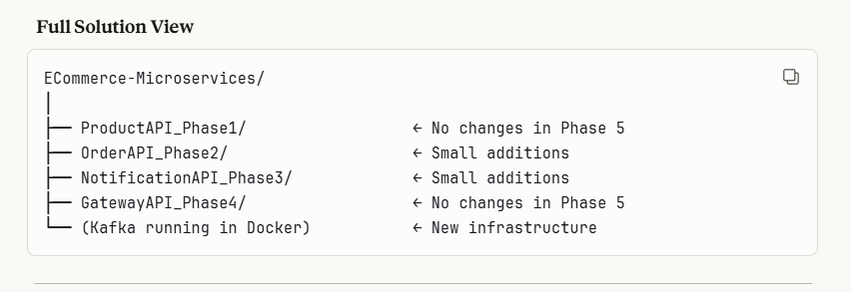

PACKAGES TO INSTALL
- OrderAPI – install the Confluent.Kafka package
- NotificationAPI – install the Confluent.Kafka package
These 2 api’s we already installed RabbitMq, so again we are inbuilting the Kafka
- Kafka server – Via Docker (like Rabbit Mq)
Kafka needs 2 things to run. Run these commands one by one

Step 1 : Create a Docker network (so kafka containers talk to each other)
docker network create kafka-network(run in any terminal)
Step 2 : Run Kafka (new Kraft mode – no zookeeper needed) – docker run
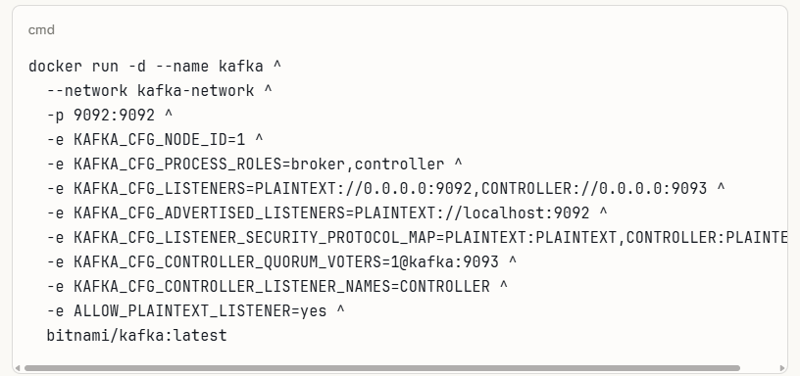

Step 3 : Verify Kafka is running – docker ps

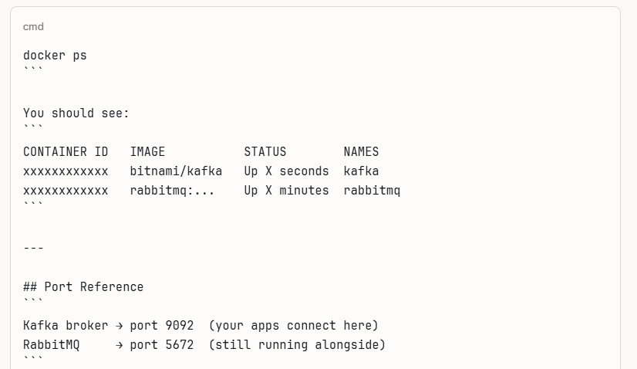
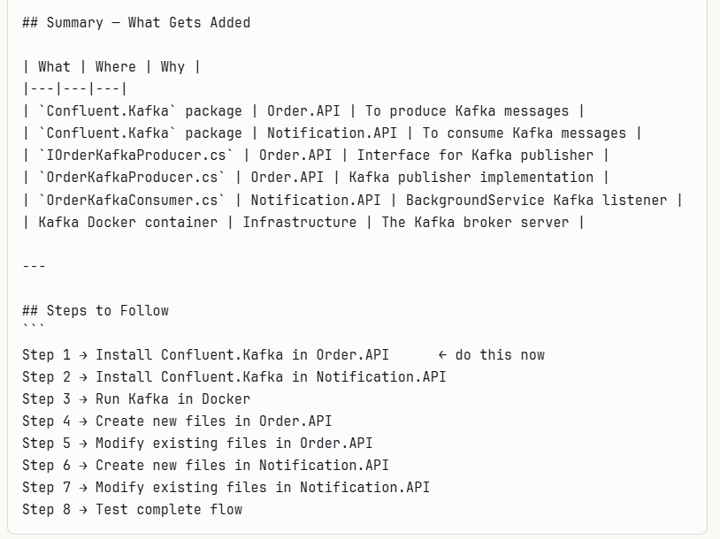
STEPS OF EXECUTION
- Install Confluent.kafka in OrderAPi which is already existing - dotnet add package Confluent.Kafka, kafka package will get installed for receiving the messages
- Install Confluent.kafka in NotificationAPI
- Create a docker network in any terminal or powershell to run– open command prompt and install this
- I opened power shell and give the below commands
- docker network create kafka-network
- Give the docker run commands fully as mentioned in below code ,so to pull the kafka images into the docker
- 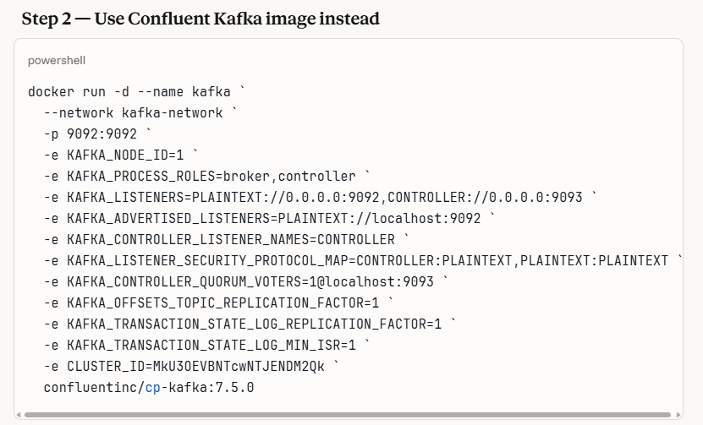
- If you want to remove the containers use “docker rm kafka”
- Check logs if exist - docker logs kafka
- Verify whether the Kafka has been installed – docker ps, you should see both the names Kafka and rabbitmq, then only the kafka is installed, from the below console, both are running correctly
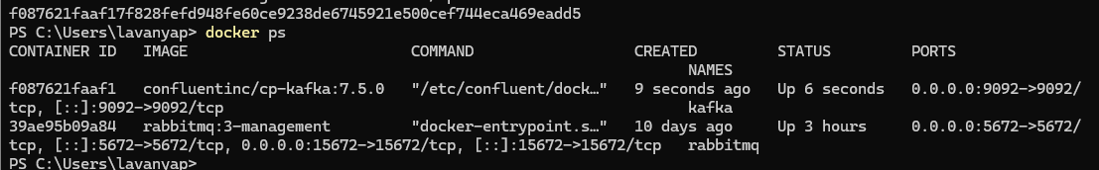
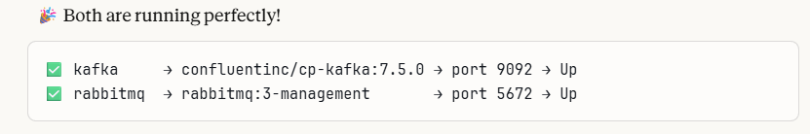
In the below docker if you see you would find that both kafka and rabbit mq will be running
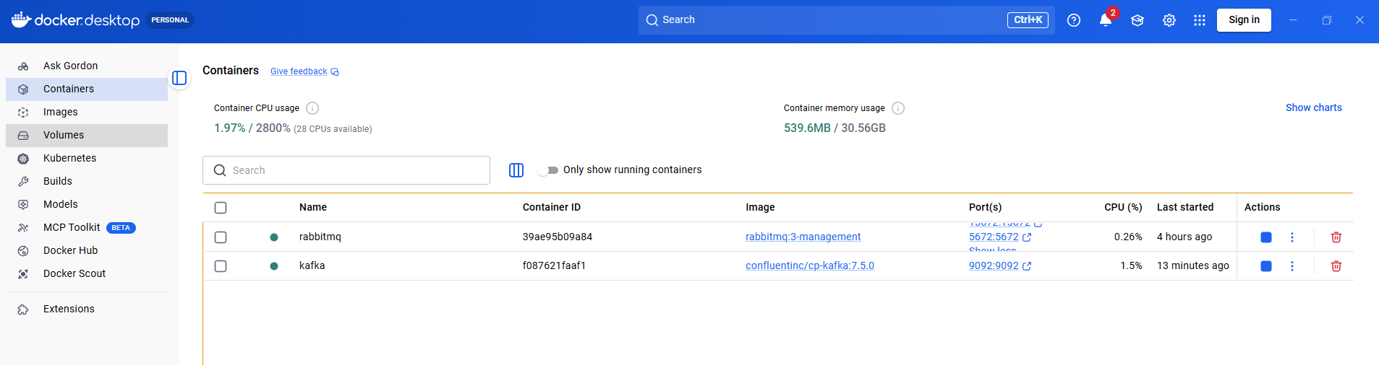

- OrderAPI- Create KafkaProducer Folder, and inside the folder create 2 files
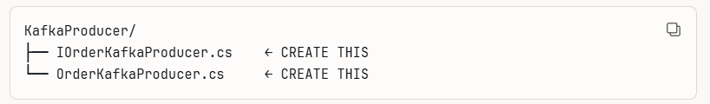

- Code explanation of above folder
- // Create Kafka message
- // Key = OrderId.ToString() → ensures all events for same order
- // go to same partition → maintains order of events
- // Value = JSON payload

var message = new Message<string, string>
{
Key = orderCreatedEvent.OrderId.ToString(),
Value = messageValue
};

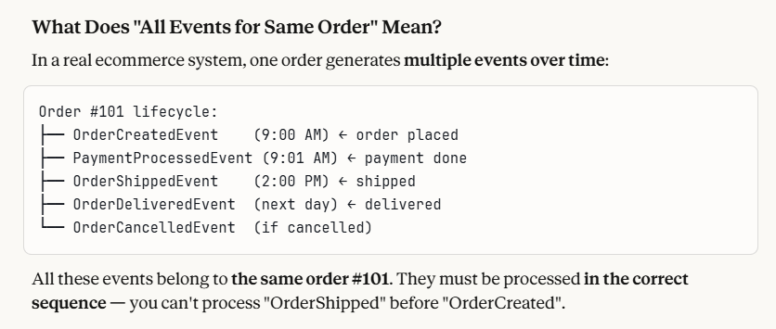
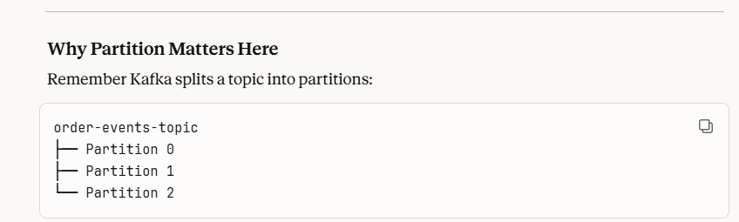
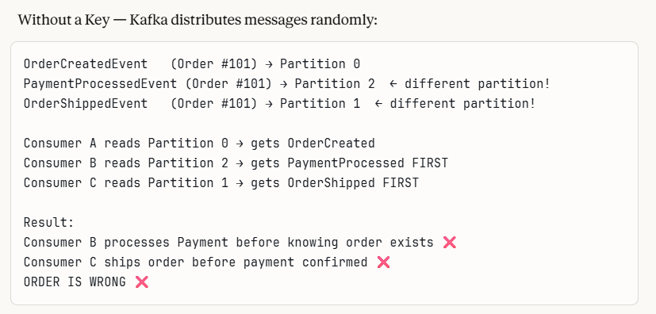
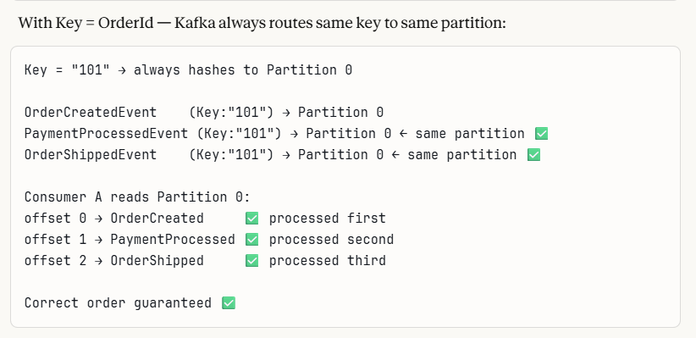

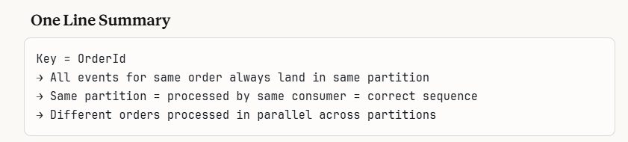

6. PublishOrderCreatedAsync – explanation
- messageValue – converts Csharp objects to a json string
Kafka sends only text, not csharp objects
- Message – creates Kafka message envelope.
- Key- decides which partition
Value = “{…json}” - > this is the actual content
- deliveryResult – sends the message to Kafka broker on topic “order-created-topic”
- Waits for the broker to confirm receipt – Returns delivery details

- Modify the appsettings.json in orderAPI – add Kafka connection string along with Rabbit mq

- In Program.cs add the kafka configuration as that of the rabbit mq –

builder.Services.AddSingleton<IOrderKafkaProducer, OrderKafkaProducer>();
app.Services.GetRequiredService<IOrderKafkaProducer>();

- Now next step is to create folders in notificationAPI

- 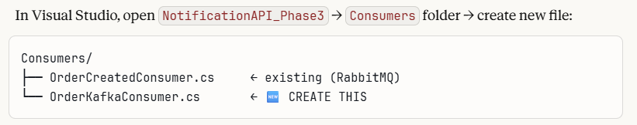

- Create orderkafkaconsumer.cs

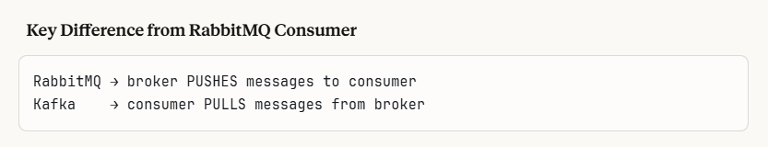

- COMPLETE FLOW WHEN ORDER IS PLACED – KAFKA SIDE WITH METHOD EXPLANATION
1. 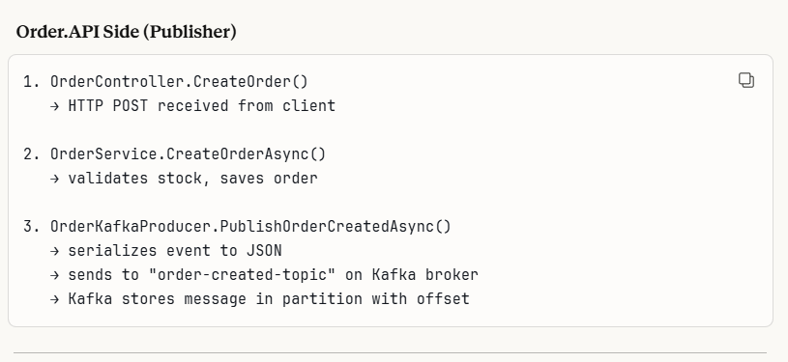
2. 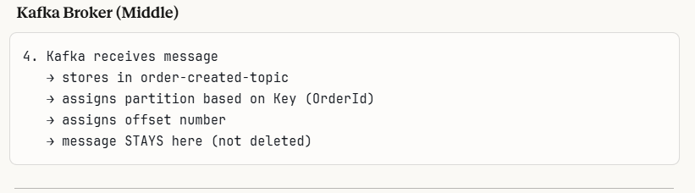
Now the user who all created the orders is stored as messages in Kafka, now which all services wants to know the user created order details ,they need to consume it
3. it may be any consumers or any services ,as of notificationaPI is used as one consumer of the kafka messages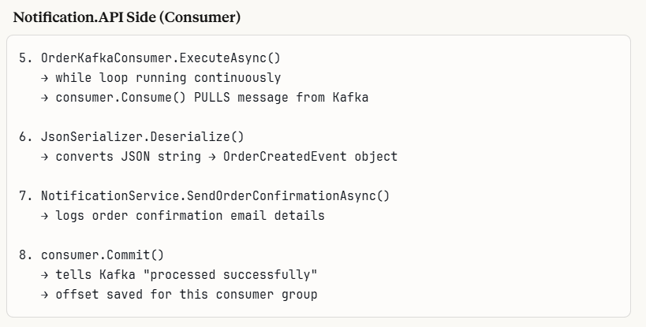
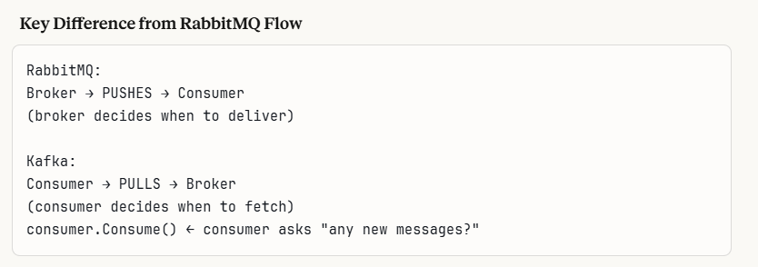

- After this make modification in appsettings.json and program.cs in Notification.API – need to add kafka connection string
- After this build both orderAPI and notification API as we completed adding the folders and code part
- Important – Now run all the services in the following added with opening the terminals in the below correct order
- Terminal 1 – ProductAPI- dotnet run
- Terminal 2 – OrderAPI – dotnet run
- Terminal 3 -NotificationAPI- dotnet run
- Terminal 4 – Gateway - dotnet run

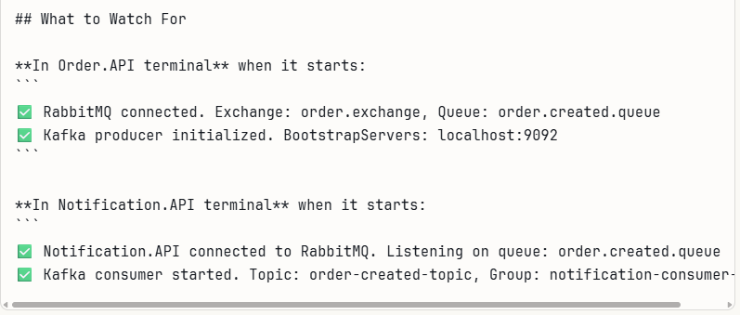

Before running lets us see the flow journey of kafka through the code

- The user places an order in the order service, where the PublishOrderCreatedAsync method is defined which calls the kafka producer
- Message sent to Kafka broker
Your code from the orderkafkaproducer.cs calls
var deliveryResult = await _producer.ProduceAsync("order-created-topic", message);

- Behind the scenes
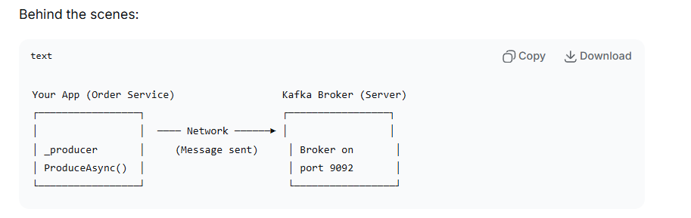
When you create or place an order , the order id, user id which will be the key is saved in the kafka broker

- Broker receives and stores the messages
The Kafka broker:

- Receives your message
- Validates it (checks topic exists, you have permission)
- Appends it to the correct partition (through hashing refer theory notes)
- Assigns an offset number
- Replicates to other brokers (if configured)
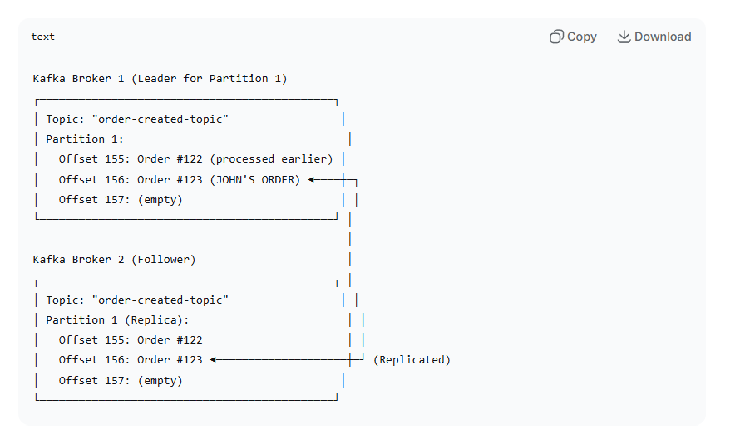

- Acknowledgement returns to your app
This is mentioned in orderkafkaproducer , inside the producerconfig – Acks =acks.leader,
Once the broker confirms it will be returned to the app regarding the confirmation

- Message waits for the consumer (other services which we created, that is other api’s), all the messager from the producers waits in the kafka server
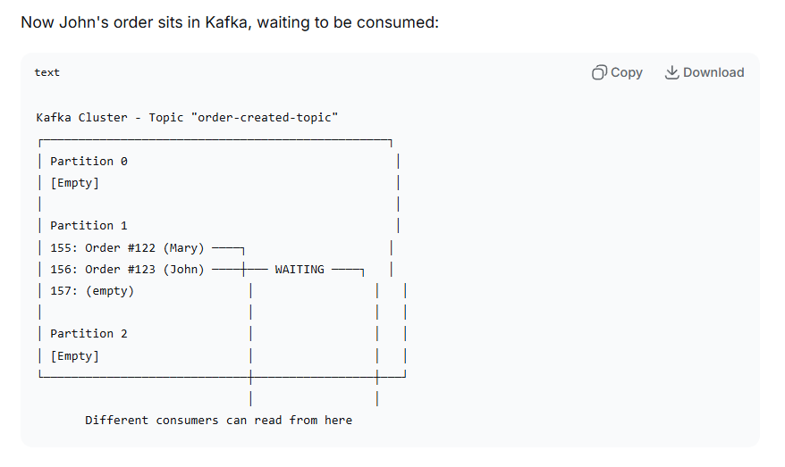

- Consumers come into play
Once the messages are stored in the kafka ,the other api’s who ever wants to access the order details which are stored as messages in kafak can be accessed by the consumers
Ex – Emailconsumer (can take the order details from the kafka and process the messages )
Payment consumer (can take the order details from the kafka and process the messages)
If any one consumer crashes the process wont be stopped, other consumers would be accessing the things

- Multiple consumers read the same message

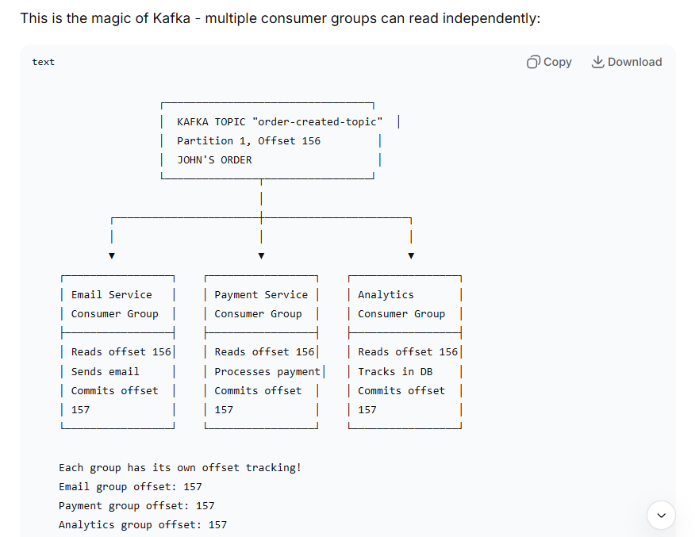

WHAT HAPPENS WHEN THE CONSUMER CRASHES

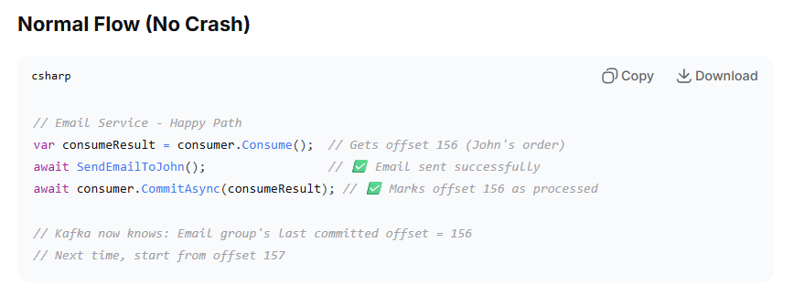
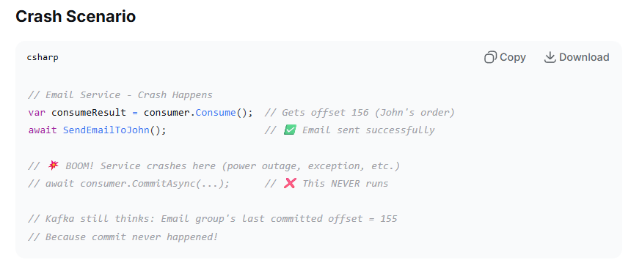
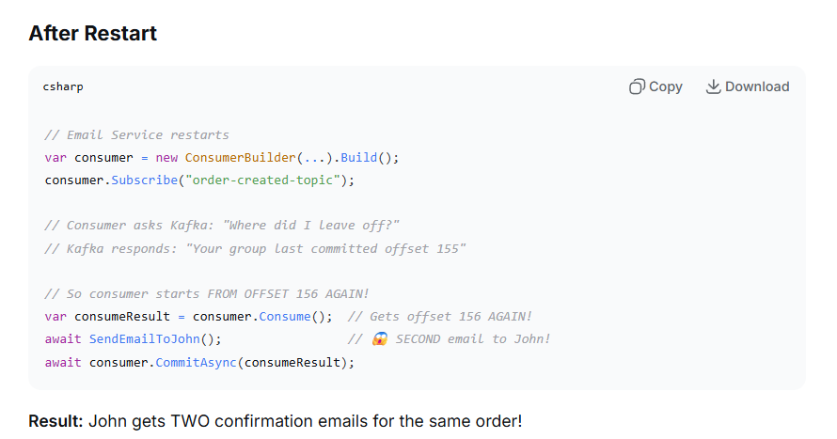

What is Idempotency?

Idempotency means that performing the same operation multiple times has the same effect as doing it once., in code you have to check whether there are any idempotent
Eg - var alreadySent = await _db.OrderEmails.AnyAsync(x => x.OrderId == order.OrderId);

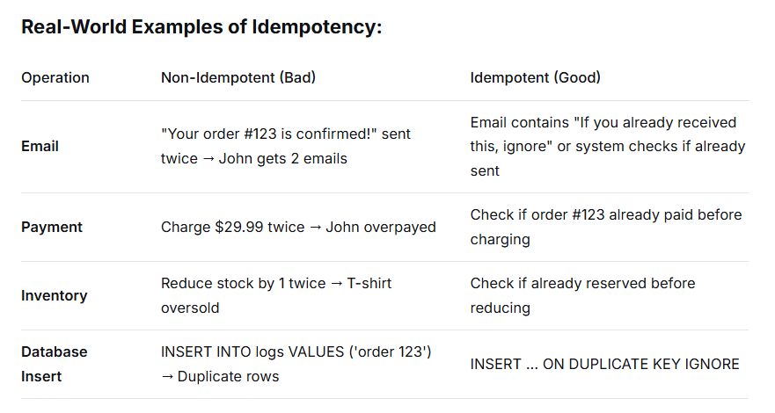

- Message Retention
The messages in the kafka broker will remain for 7 default days, so once the message or request is delivered it wont disappear or not get deleted
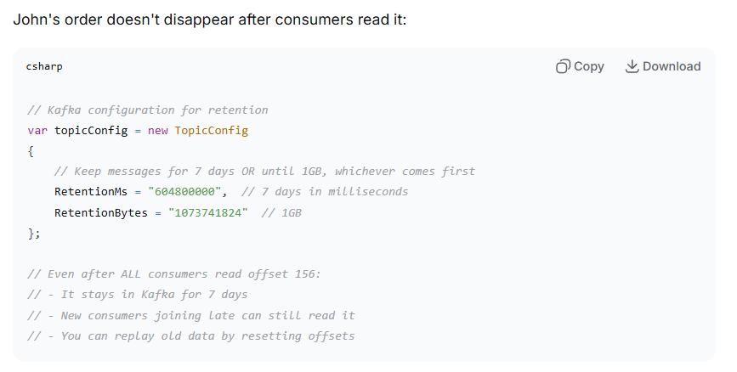

- Kafka end-to end flow for john’s order
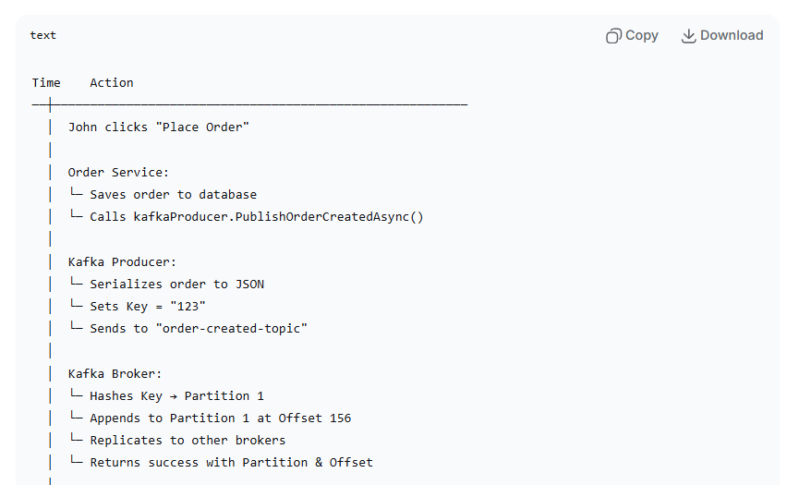
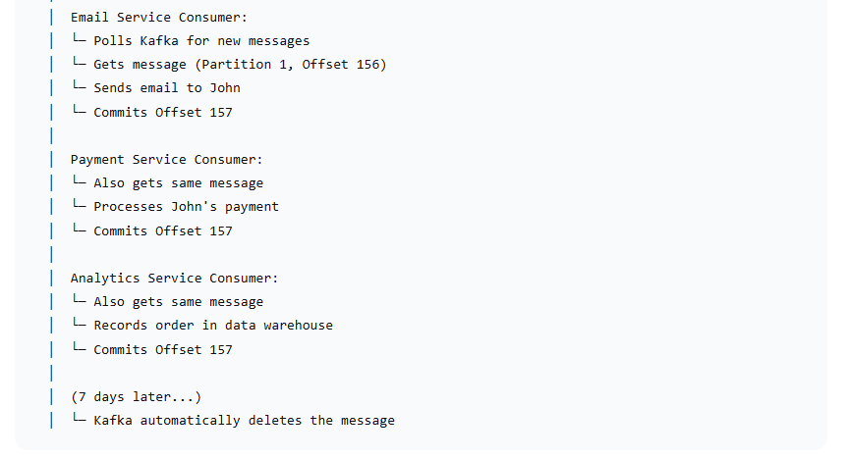
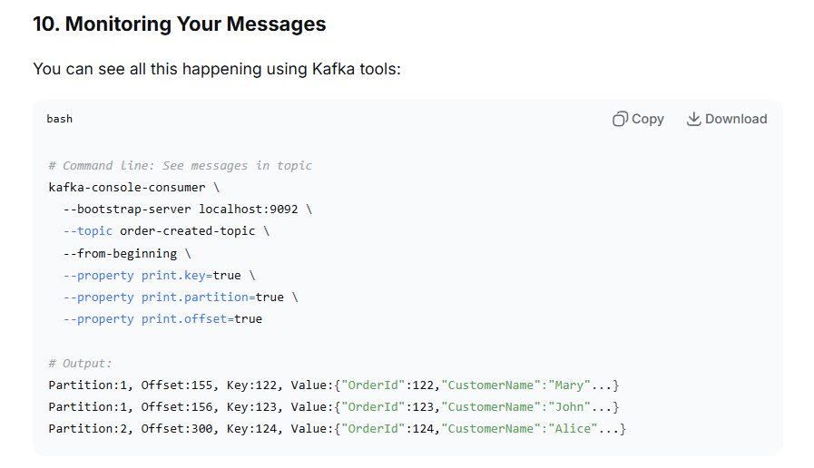

NOW RUN ALL THE SERVICES STRICTLY IN THIS BELOW ORDER

- Terminal 1 — Product.API:
- Terminal 2 — Order.API:
- Terminal 3 — Notification.API:
- Terminal 4 — Gateway:

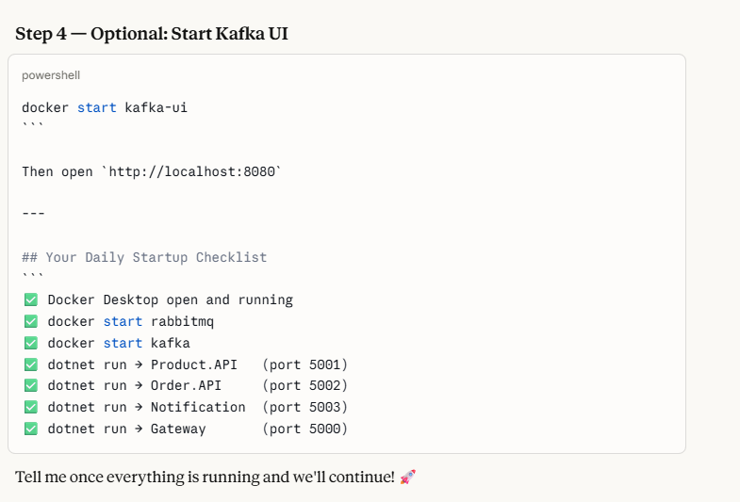

Important - If you want to see the messages in the Kafka,

Click Topics in the left sidebar → click order-created-topic → click Messages tab at the top. –

Imp - here I have used this url (http://localhost:5000/api/orders)in the postman and submitted the records, those records have been shown in the message queues in RabbitMQ , for the messages to be shown ,I have to stop the notification api, if the notification api is running then the messages will get consumed , the messages does not get viewed in the RabbitMq

But in the Kafka, even if the notification api is running, the messages gets consumed, then also the messages will get shown in the queue for a certain time period like the screenshot below, this is the difference between rabbit mq and kafka

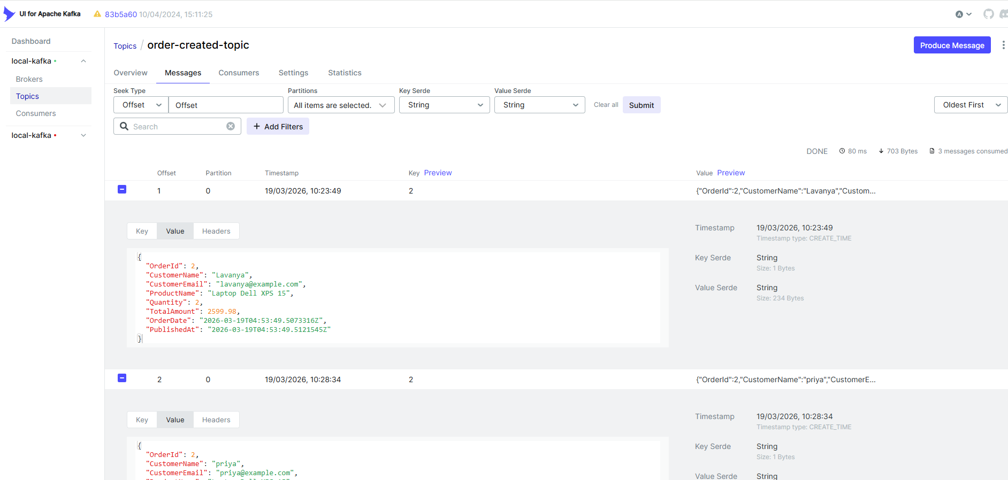

## Key Thing to Notice

RabbitMQ → messages GONE after consuming ❌

Kafka → messages STILL HERE after consuming ✅ can replay from offset 0 anytime!

NEXT PHASE – DOCKER AND CONTAINERISATION – DOCKER COMPOSE
Refer separate notes for docker contineraisation after kafka – and previous docker notes

